**Step 1:** Login to <https://developer.amazon.com/alexa> by clicking the **“Sign In”** button on the top right corner

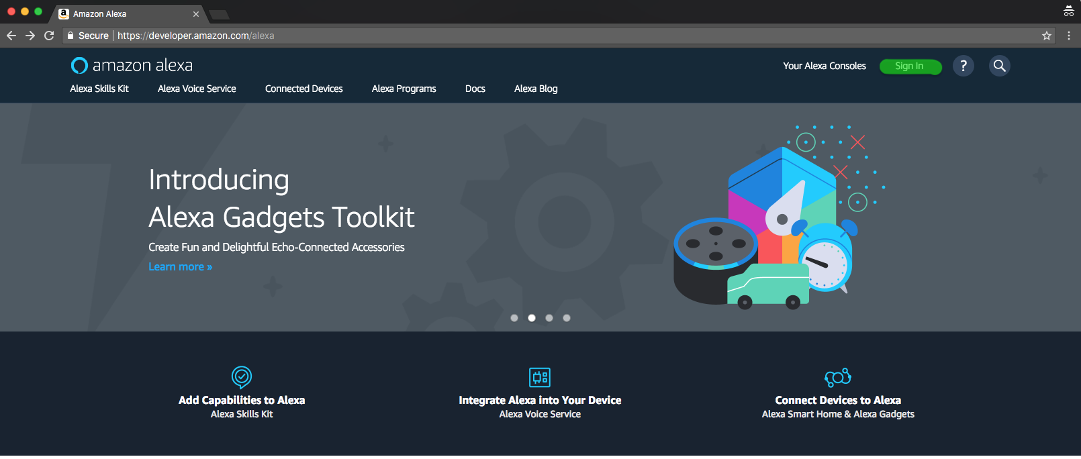

**Step 2:** Hover on “Your Alexa Consoles” on the top right and then click on “Skills”.

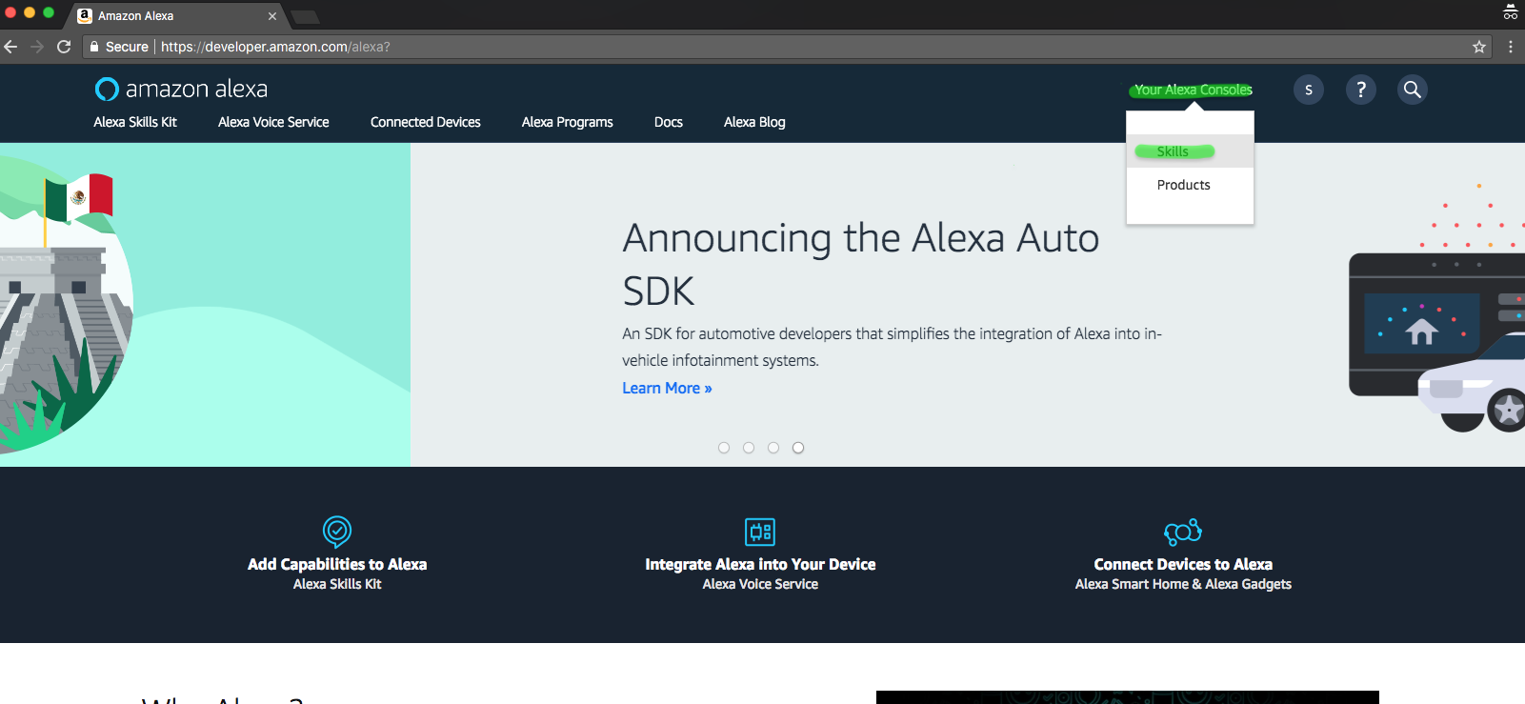

**Step 3:** Under the **“Skills”** tab click on click on **“Create Skill”** button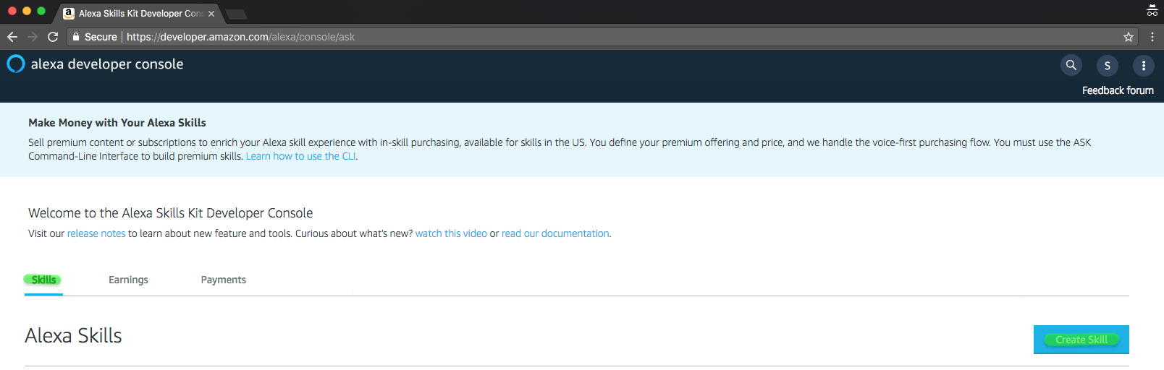

**Step 4:** Provide the **“Skill Name”** as ***Hello App*** and retain the Default Language to be English (US). Ensure the **“Custom”** model is selected and click on the **“Create Skill”** Button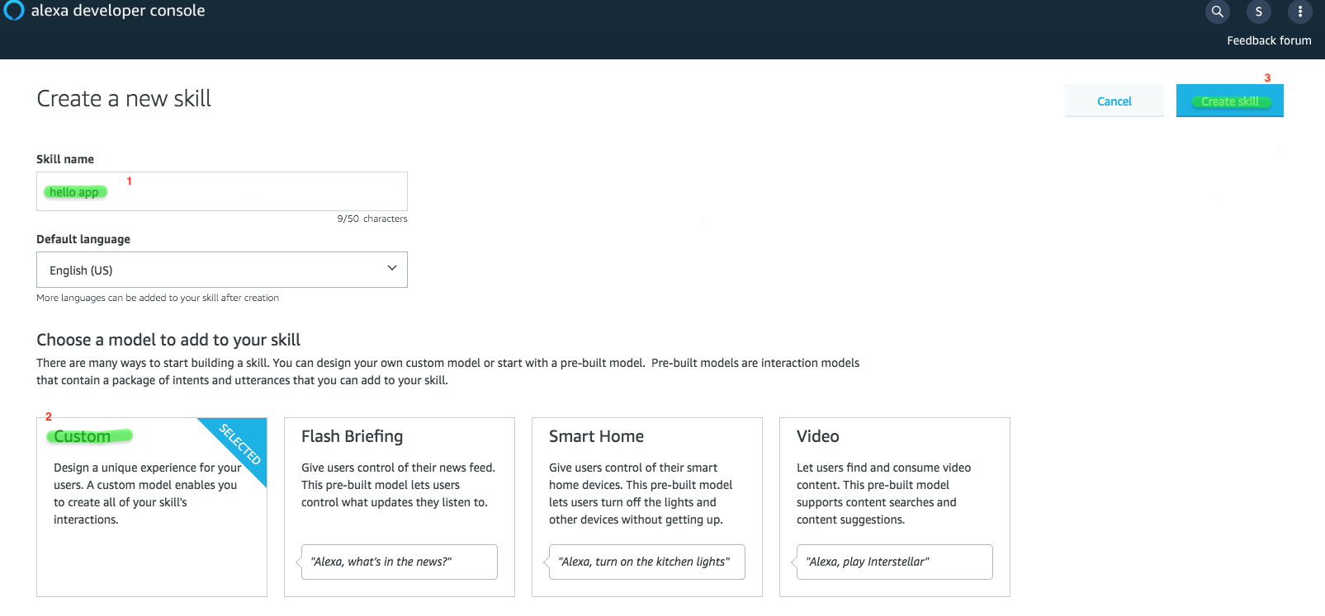

**Step 5:** Ensure that **“Start from scratch”** template is selected and click on **“Choose”** button on the top right.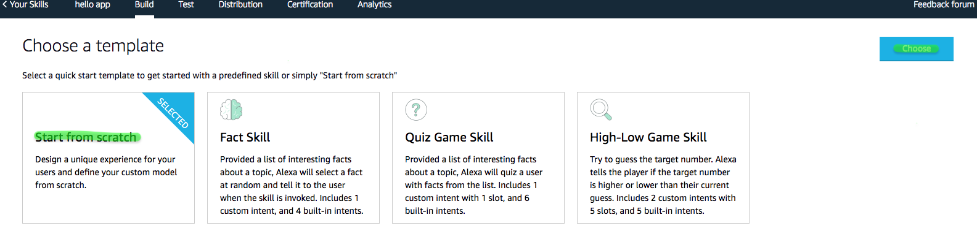

**Step 6:** Click on **“Add”** next to Intents. Under **“Create custom intent”** provide the intent name as ***helloIntent*** and then click on the **“Create custom intent”** button.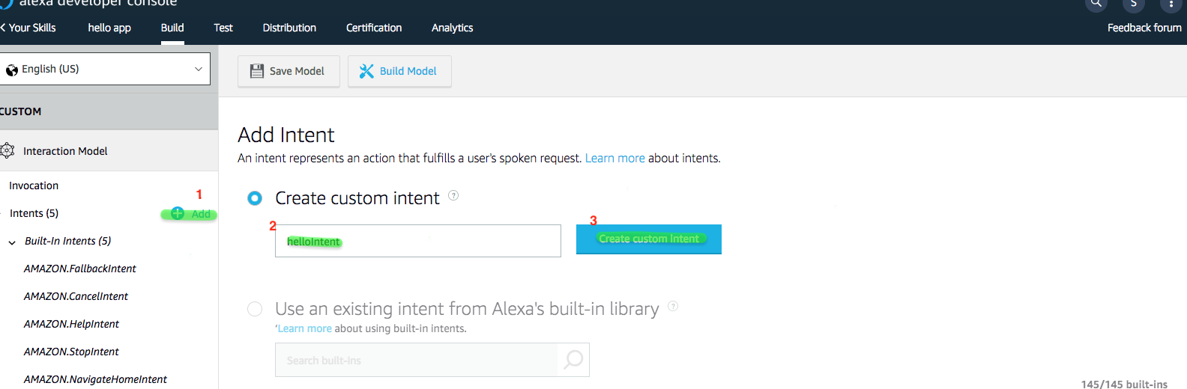

**Step 7:** Under **“Sample Utterances”** type in ***say hello to {fname}*** and press enter. This will create a **“Intent Slots”**

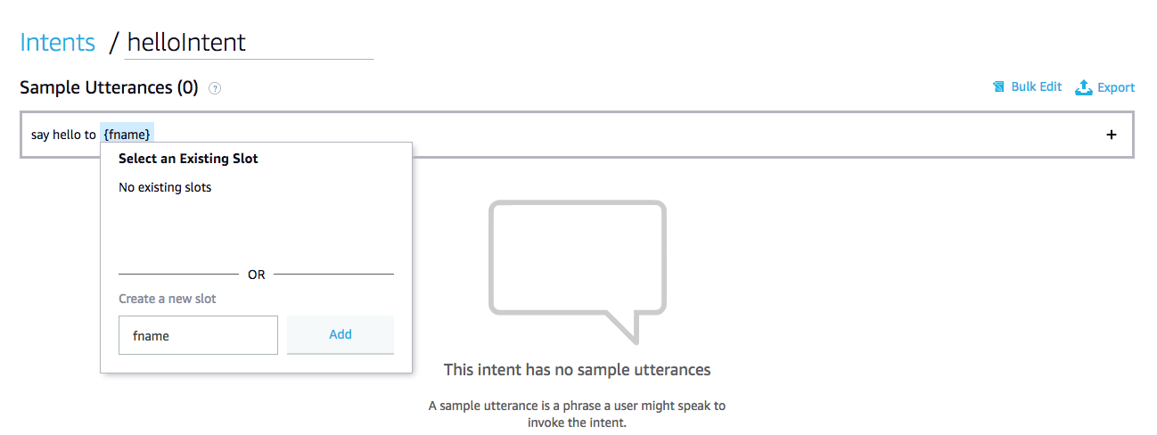

**Step 8:** Click on **“Add”**  button next to the Slot Types and under Create custom slot type, create a type named ***Names***  and click on **“Create custom slot type”** button**.**

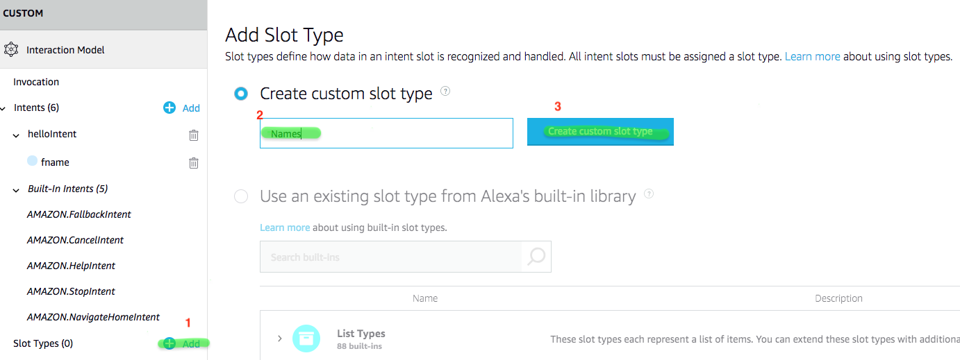

**Step 9:** Under the Slot Values add names**.** Eg: Adam, Grace etc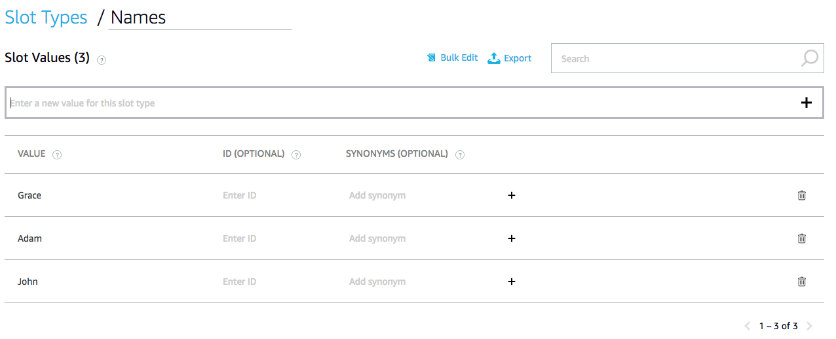

**Step 10:** Click on **“fname”** under helloIntent on the Left Navand select the **“Slot Type”** as **“Names”**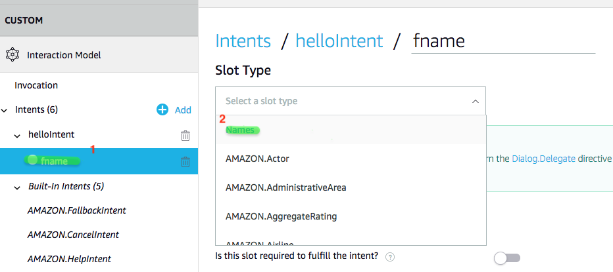

**Step 11:** Click on **“Save Model”** button. Once the Interaction Model is Saved Successfully, click on **“Build Model”**

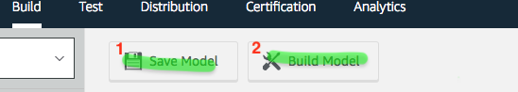

**Step 12**: Once the Build is successful click on **“Your Skill”.**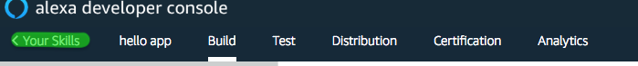

**Step 13:** Under you skill name click on **“View Skill ID**” and copy the **“Skill Id”.**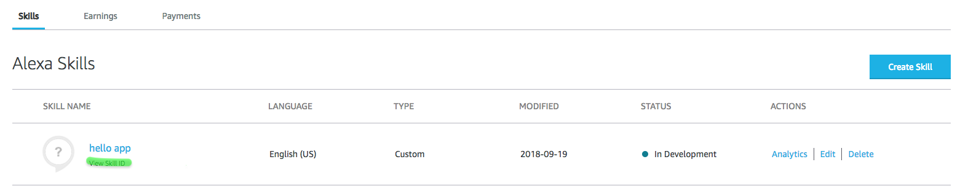

**Step 14:** Sign into your AWS account using the following link.

https://signin.aws.amazon.com/signin

**Step 15:** Once in the portal ensure you are on **“N.Virginia”** or any of the regions that support lambda function for custom skills. Then type in **“Lambda**” under the AWS Service and select it.****

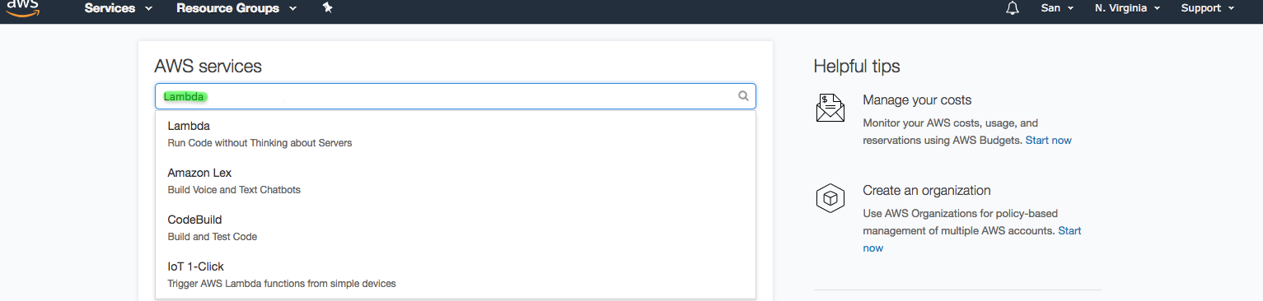

**Step 16:** Once in the AWS Lambda portal, ensure **“Functions”** is selected in the left nav and then click on the **“Create function”** button**.**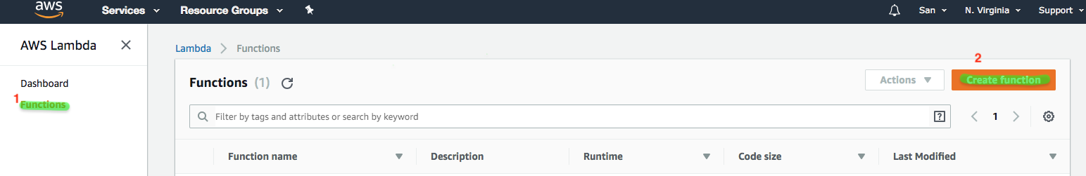

**Step 17:** Once in createfunctionselect **“Author from scratch”** and then give the name of the function as ***helloFunction.*** Select the runtime env as ***Node.js***, select Role as ***Create new role from template(s)*** , name your role as ***helloRole***  and pick the Policy Template to be “**Simple Microservice permissions”**. Then click on **“Create function”** button.

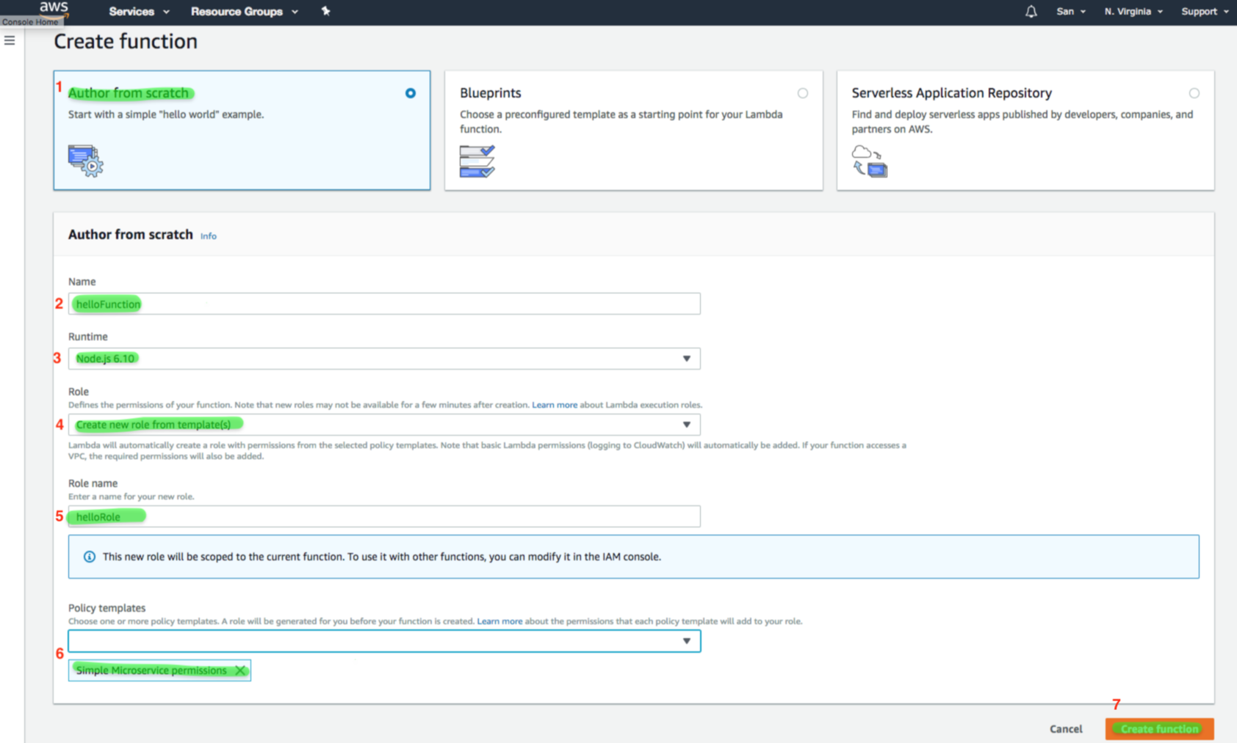

**Step 18:** Make sure you are in the **“Configuration”** tab and select **“Alexa Skill Kit”**  form the left nav.

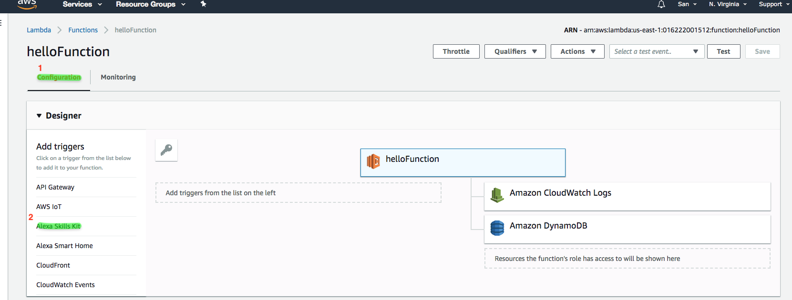

**Step 19:** Select **“Alexa Skills Kit”**. Under Configure triggers select **“Enabled”** under the Skill Id verification and provide the Skill Id that we got from Step 13and click on **“Add”** button.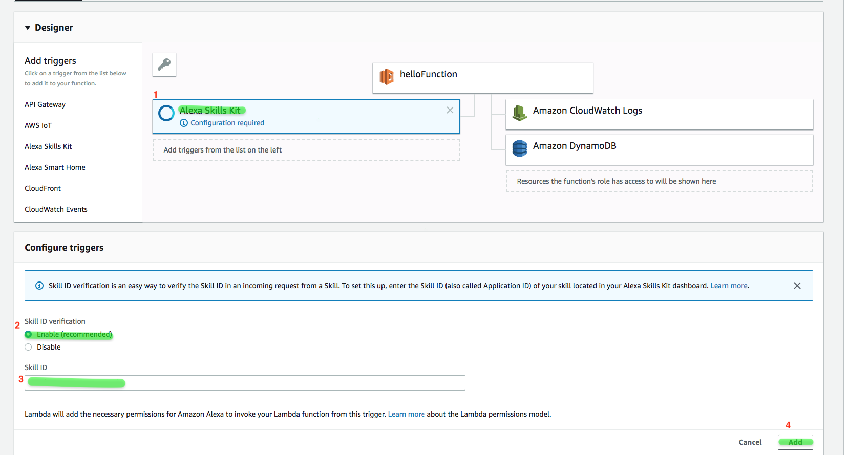

**Step 20**: Click on **“Save”** button on the top right corner.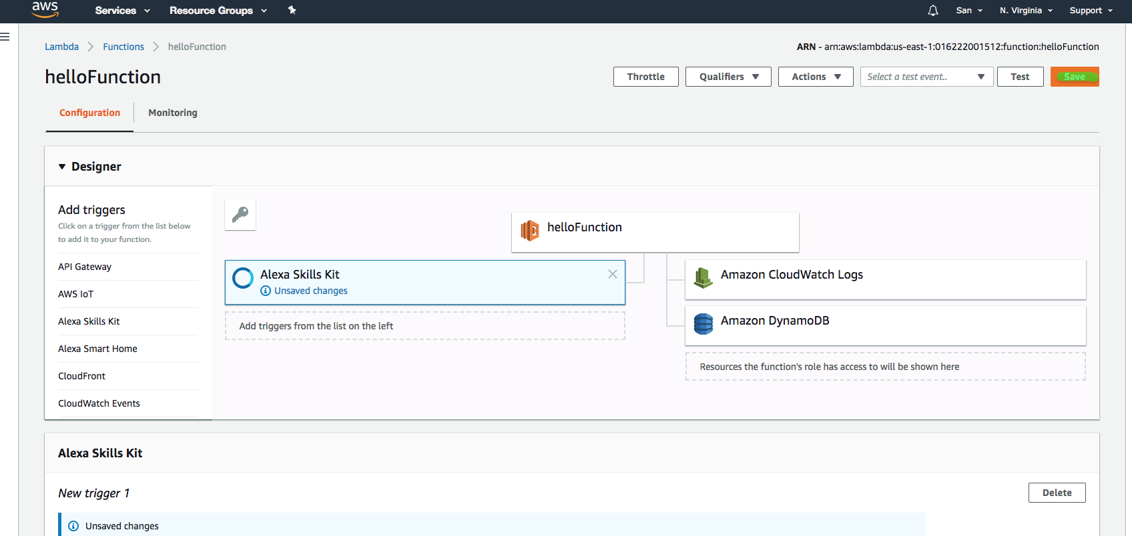

**Step 21**: Click on the **“helloFunction”**, then you will get the Function Code Tab below where in you will be able to enter the code. 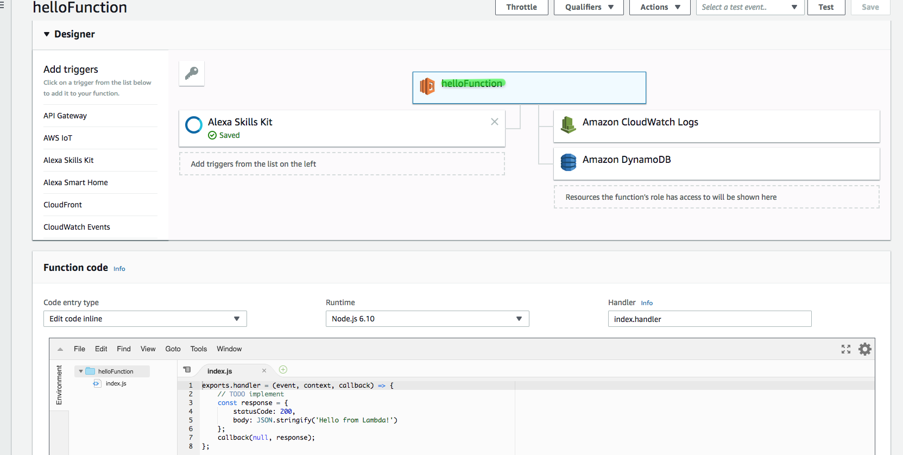

**NOTE:** Refrence to the code is present in our git hub (lambda/hello-alexa.js)

**Step 22:** Once done with coding press the **“Save”** button on the top right corner.

**Step 23:** Then click on the **“Test”** button thatis present nect to the “Save” button on the top right and provide the **“Event Name”** in the dialoge as test and provide the test json (Note this test json is present in the git as well) (test/hello-alexa-test.json) and click on the **“Create”**  button.

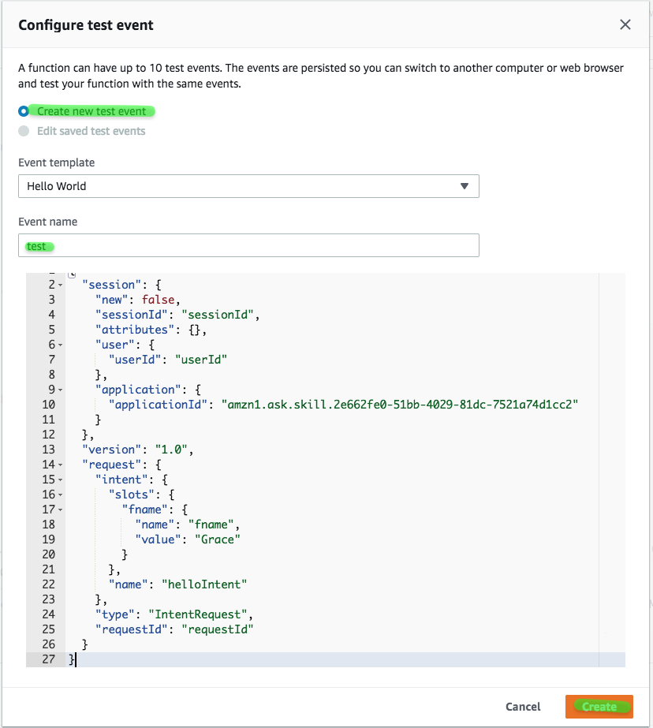

**Step 24:** Select the saved test event and click on **“Test”** buttonwhich will provide you with a sample response payload.

**Step 25:** Copy the lambda **ARN** from the top right corner.

**Step 26:** Go back to the alexa developer console at <https://developer.amazon.com/>

Select the **“Endpoint”** on the Left Nav and select **“AWS Lambda ARN”** and past the ARN that we copied in the previous step into the **“Default Region”**. Then click on **“ Save Endpoints”**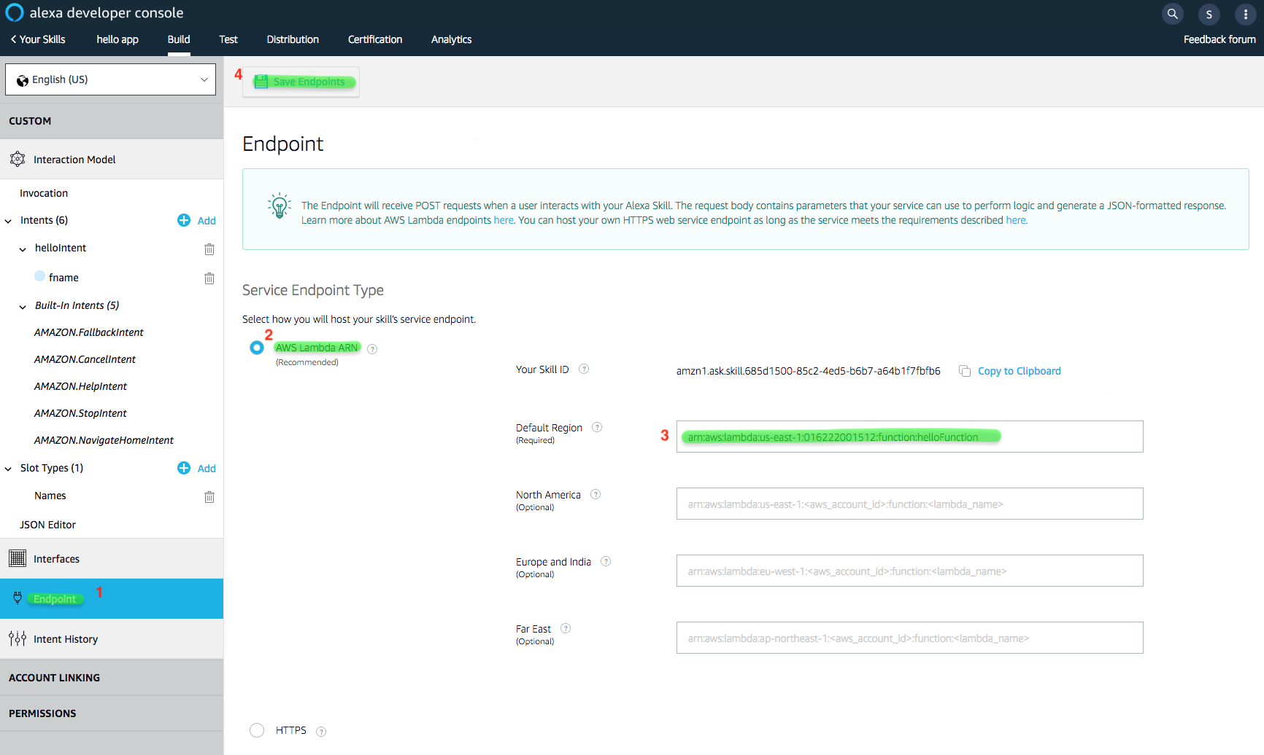

**Step 27:** Click on the **“Test”** tab on the top nav and **enable** the **Test.**

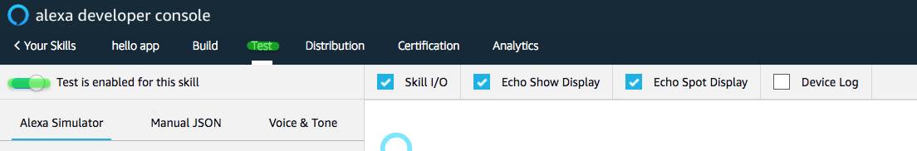

**Step 28:** Either you can ask Alexa or type in the test phrase **“ask hello app to say hello to grace”** and should get the right response back from your Lambda.

